LINQ Operator.

1-where operator:

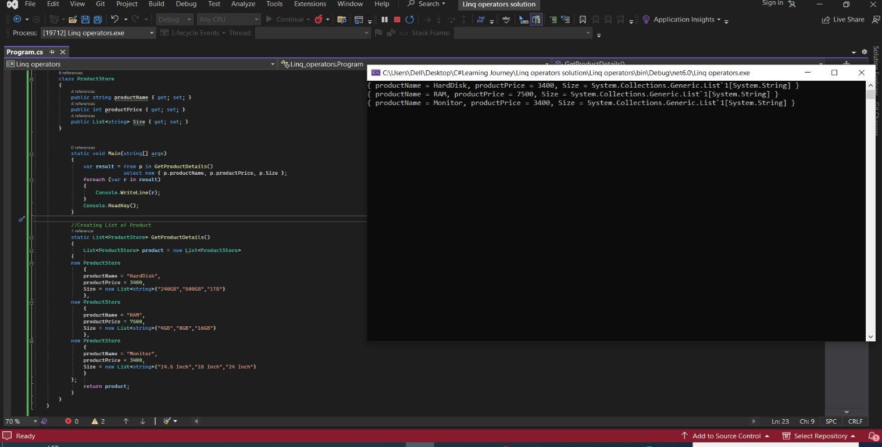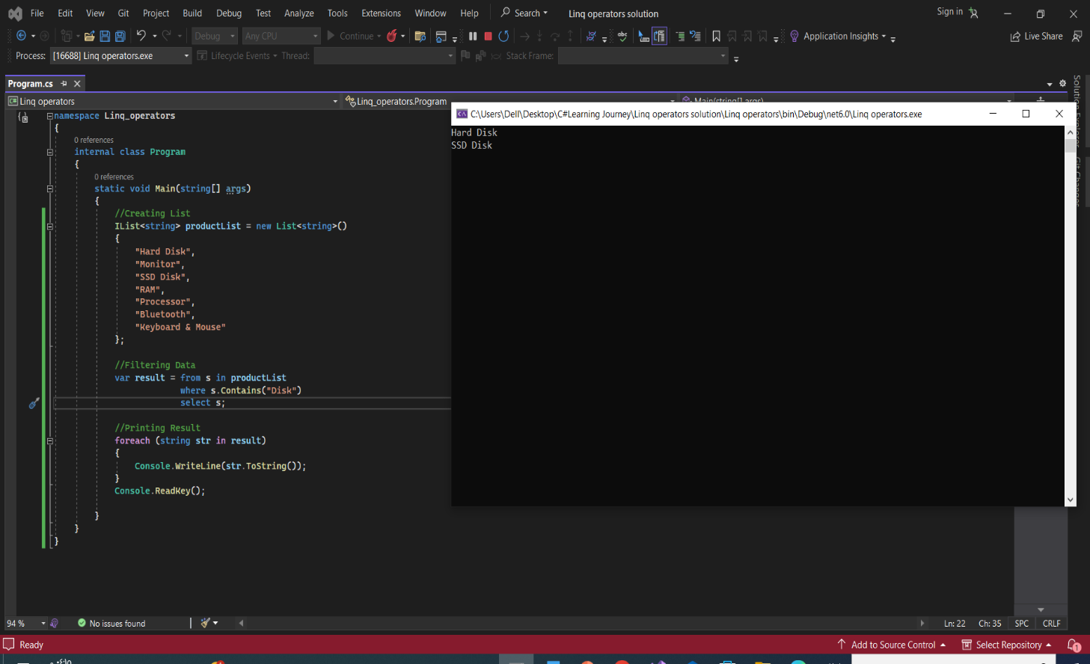2. Select operator With Example C# LINQ

3. **SelectMany With Example C# LINQ**

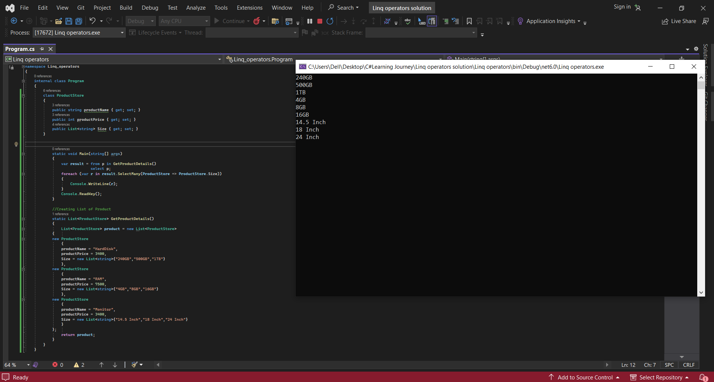

4. **OrderBy**

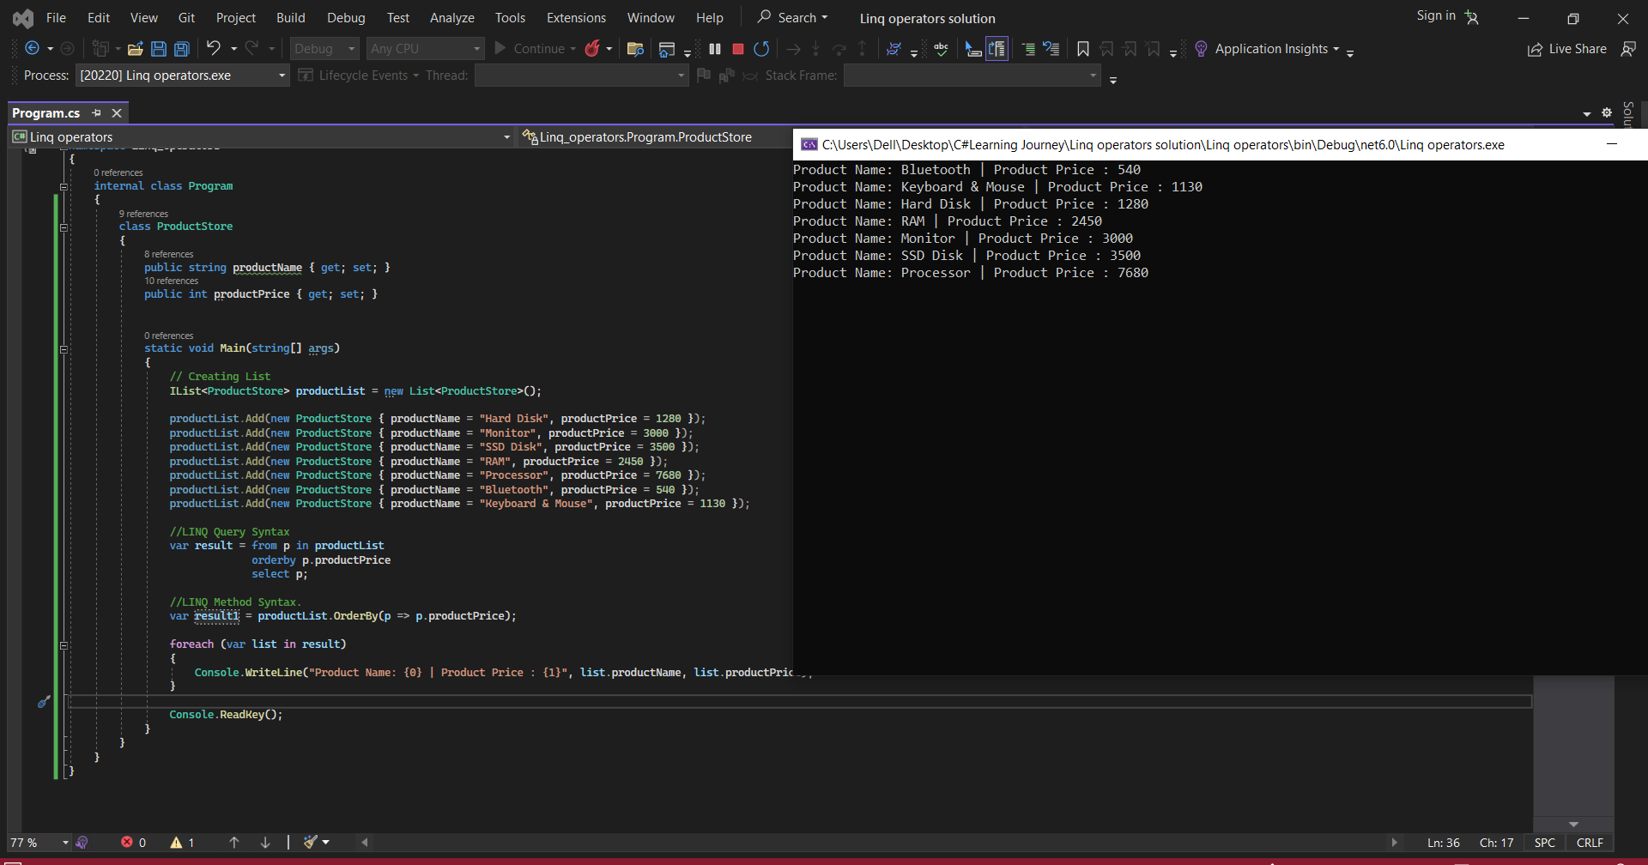

5. **order by descending**

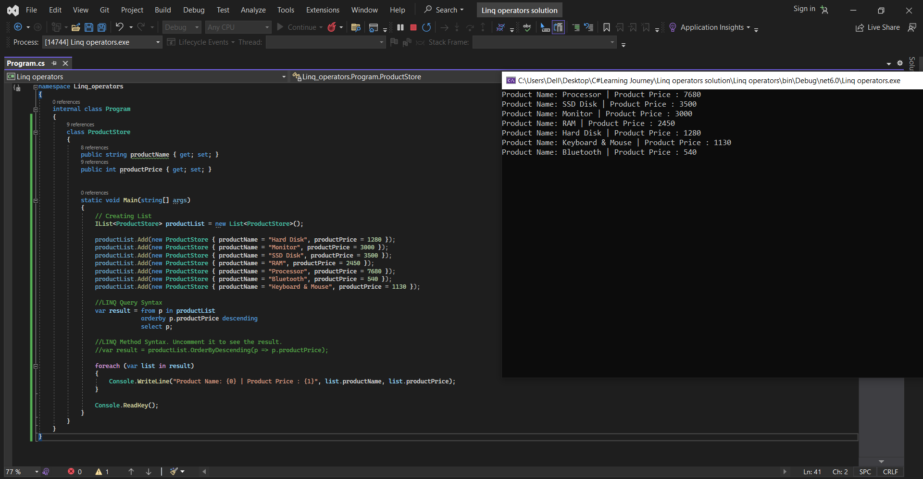

6. **THENBY**

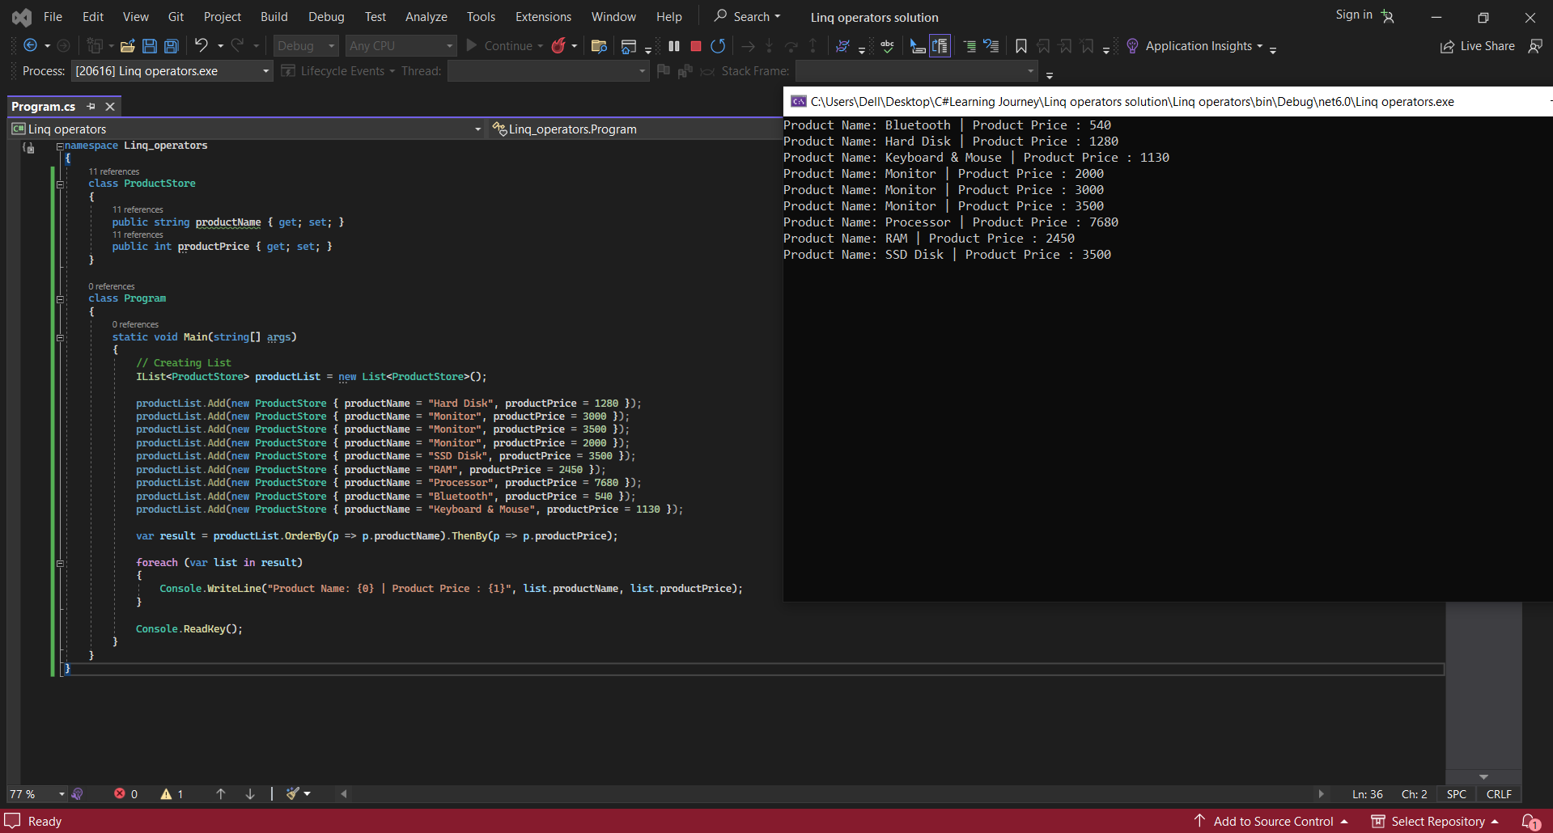

7. **THENBYDESCENDING**

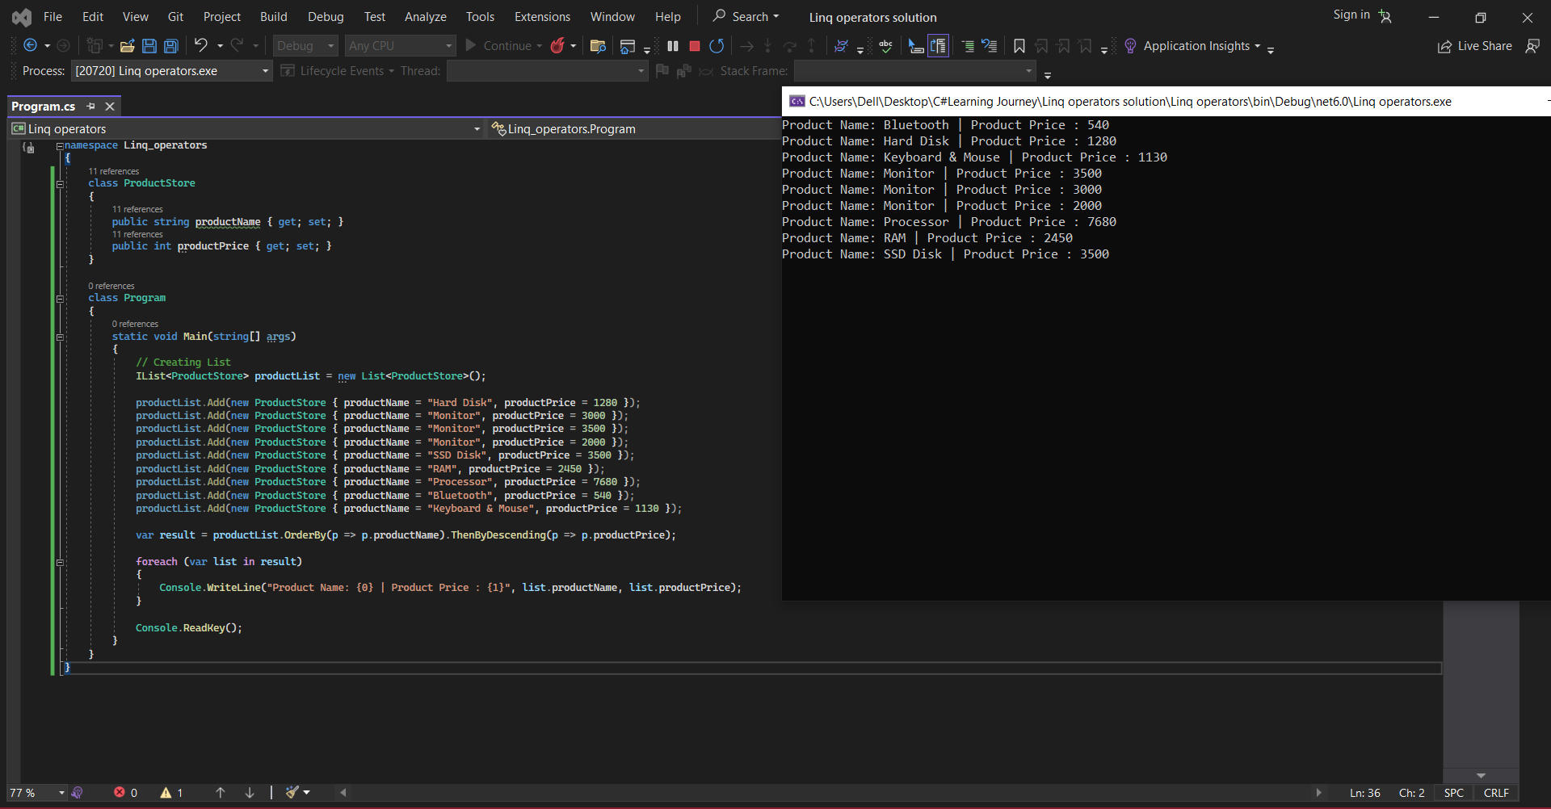

8. REVERSE

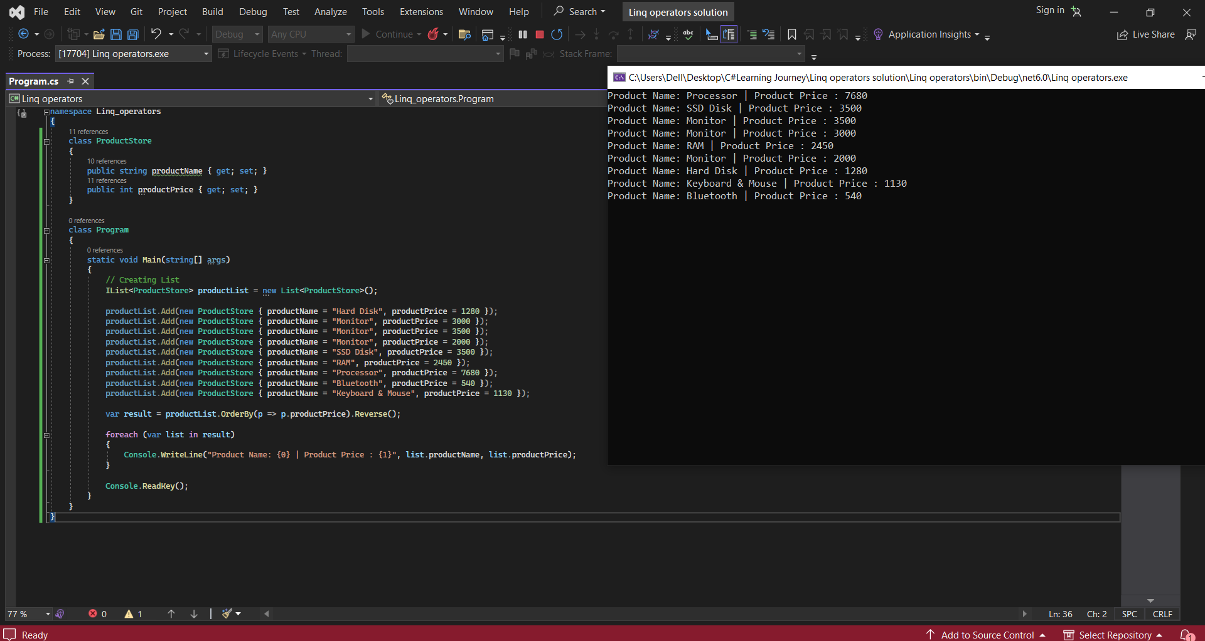

9. GroupBy

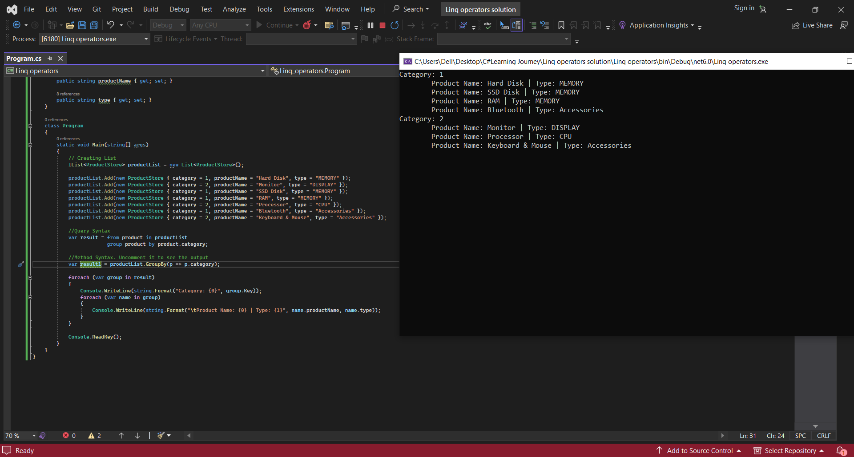

**10.MULTI KEY GROUPING**

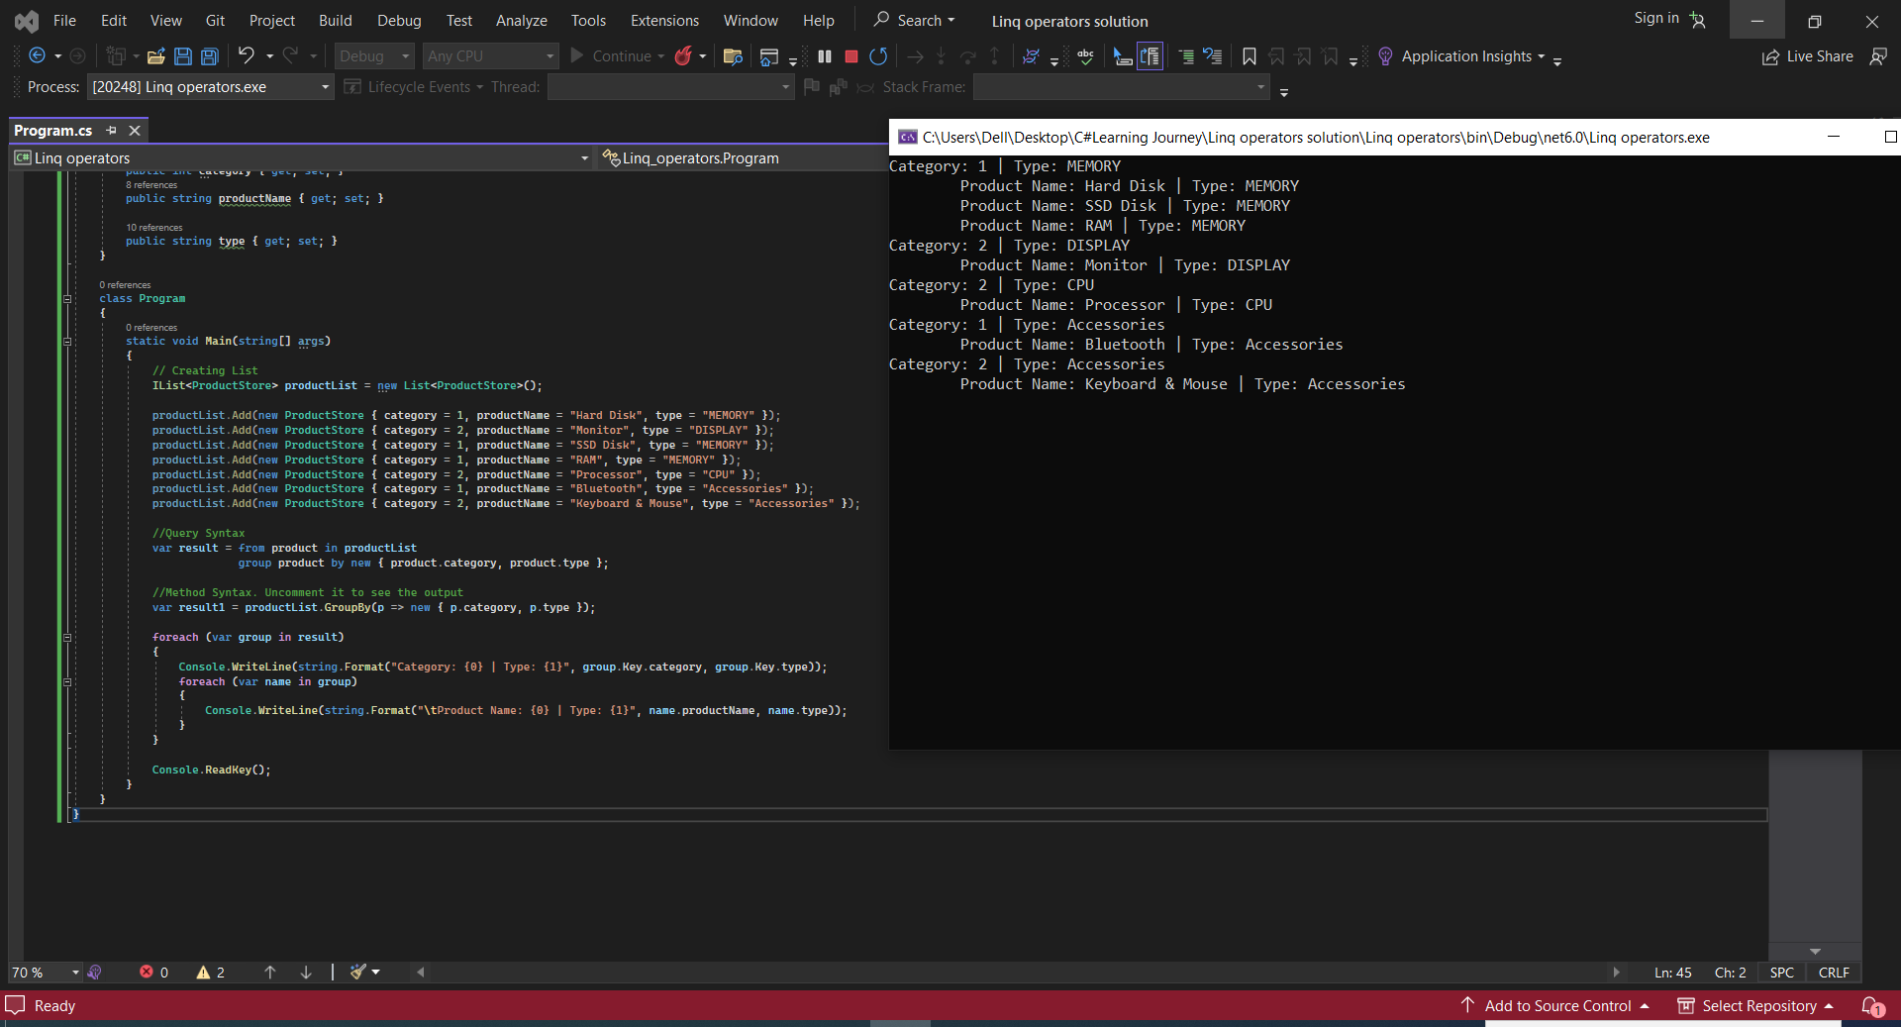

11. **GROUPING WITH SORTING**

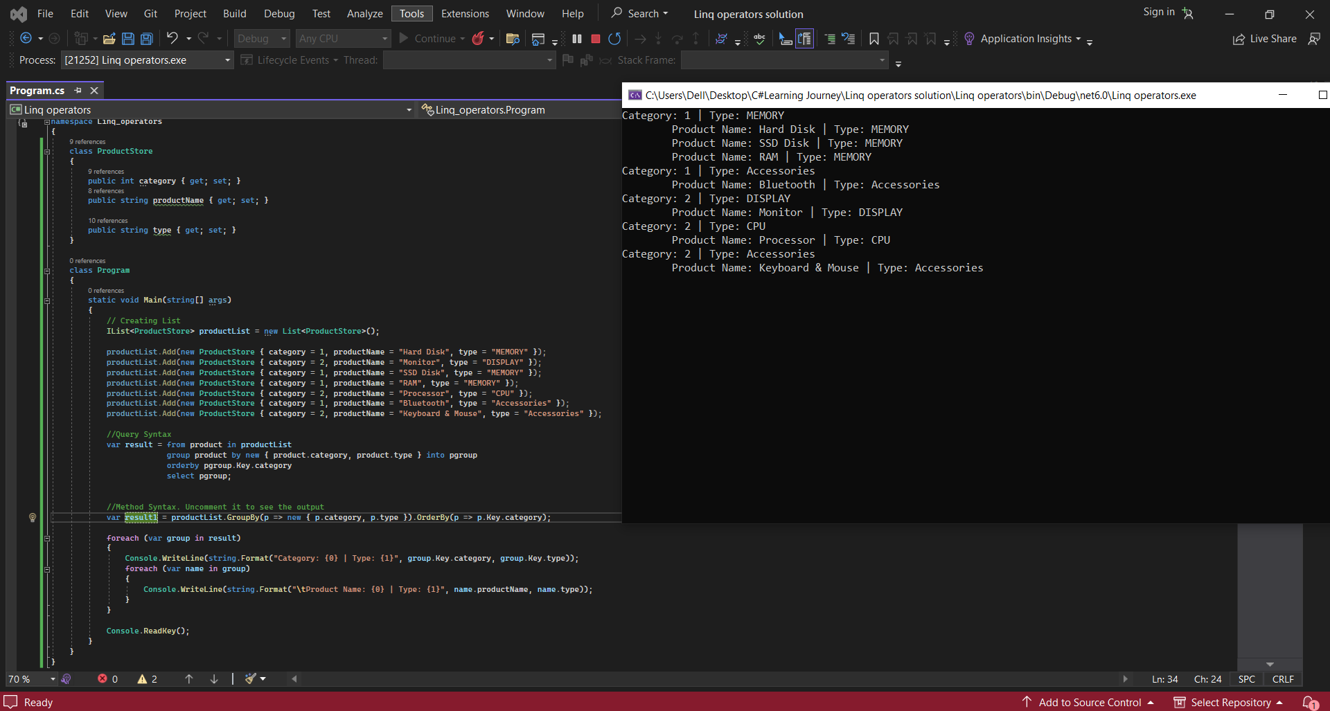

12. **ToLookup Operator**

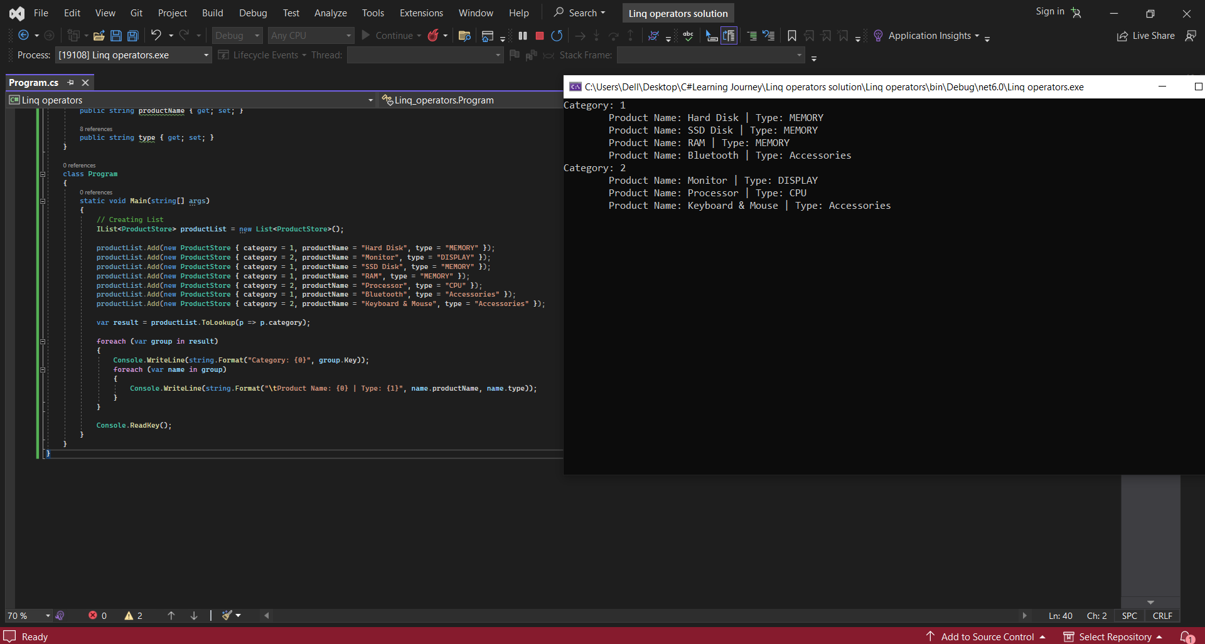

13. **LINQ – Average**

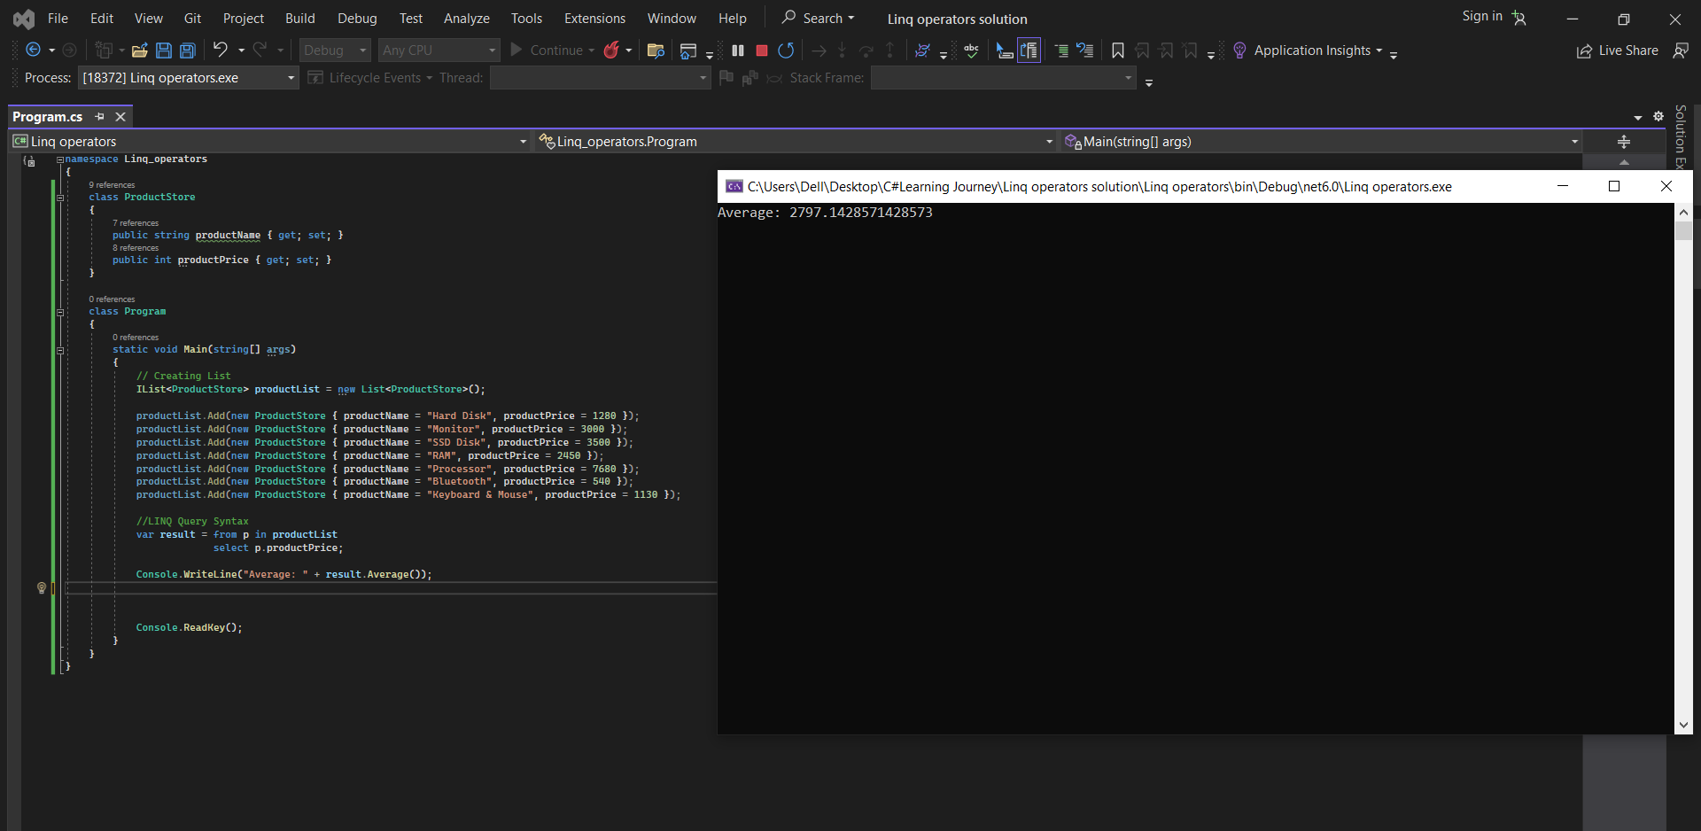

14.Count

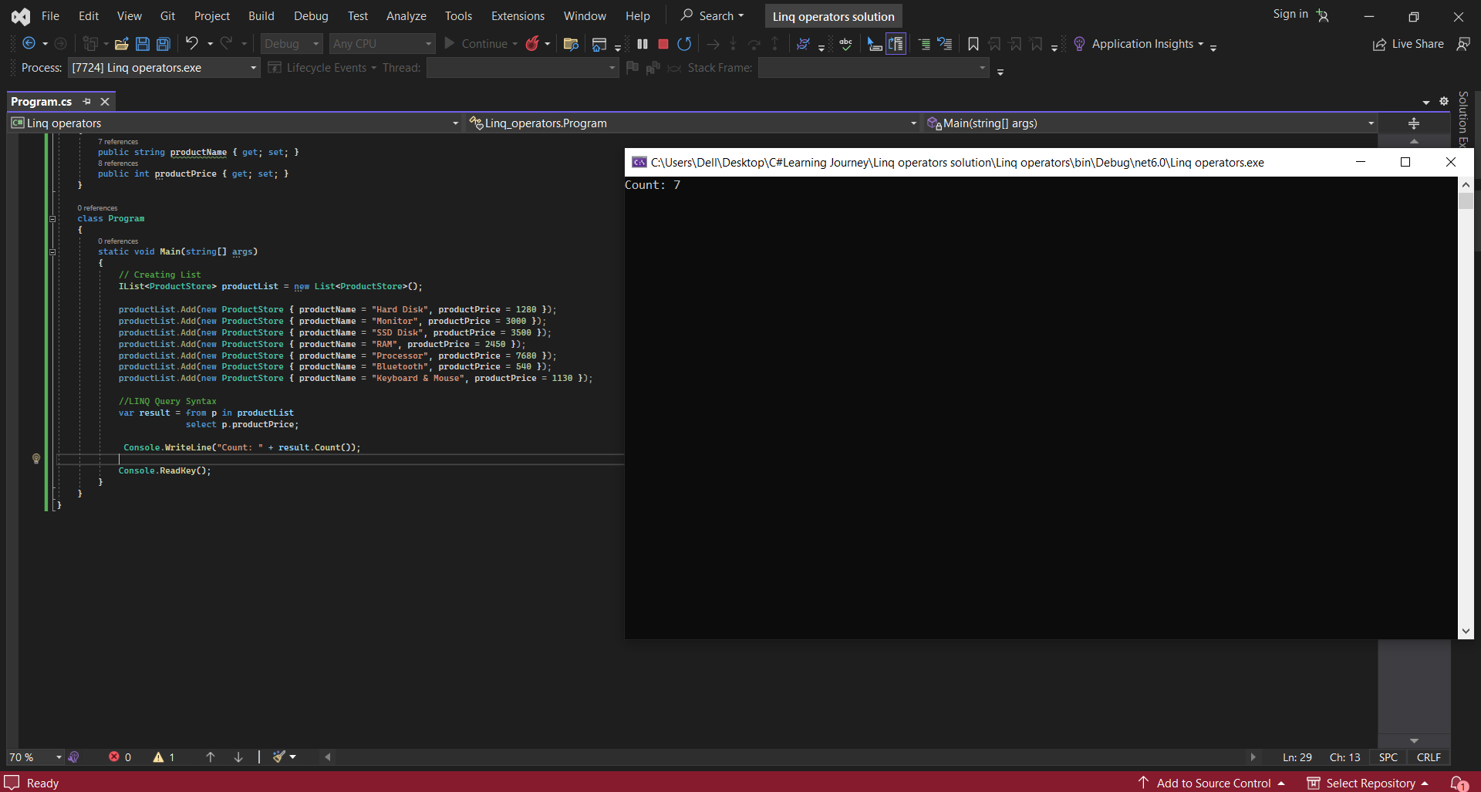

15.MAX

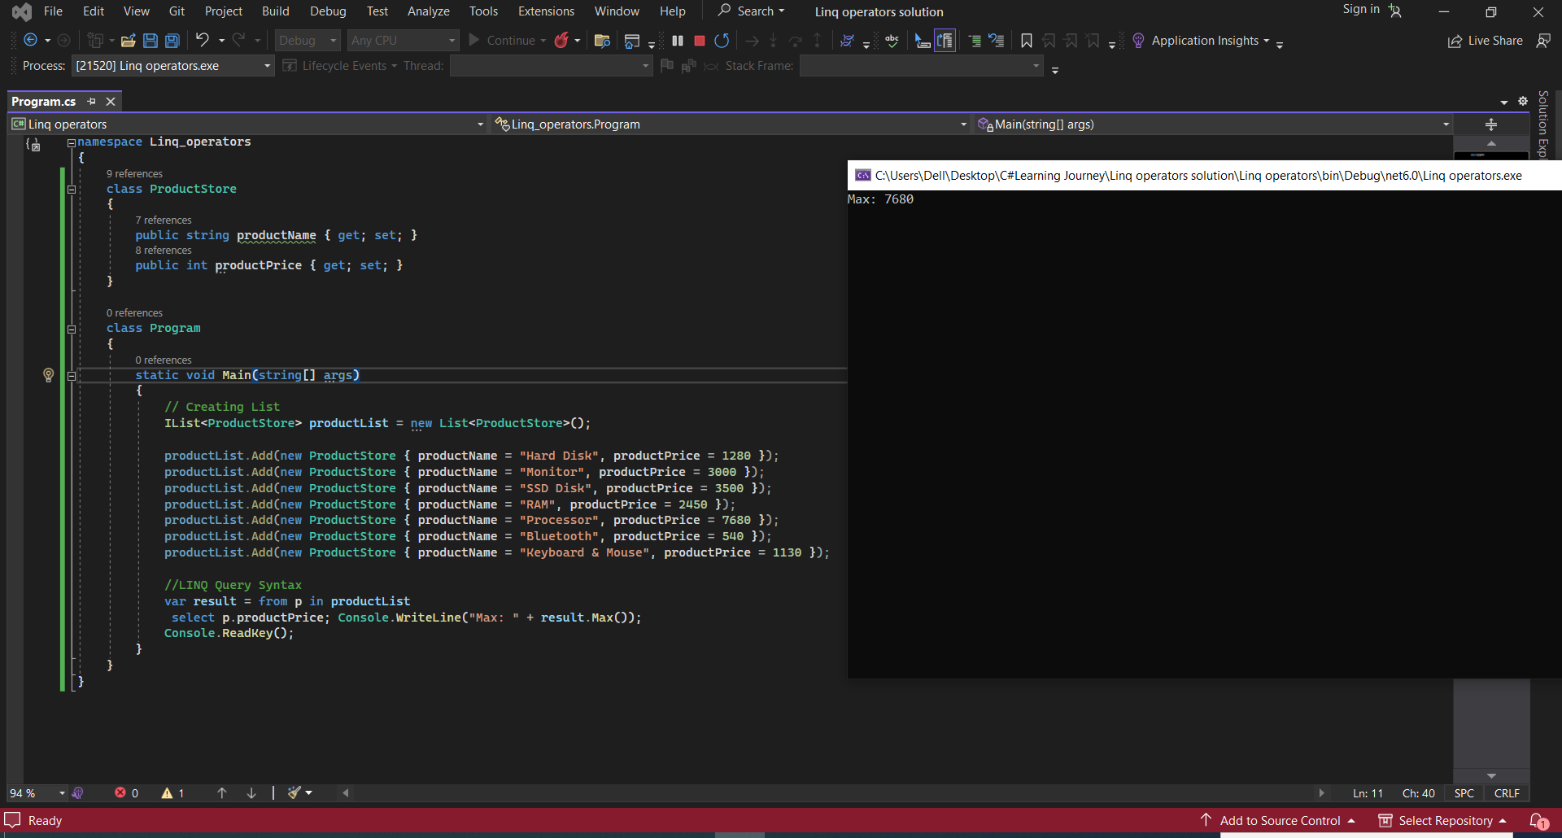

16.MIN

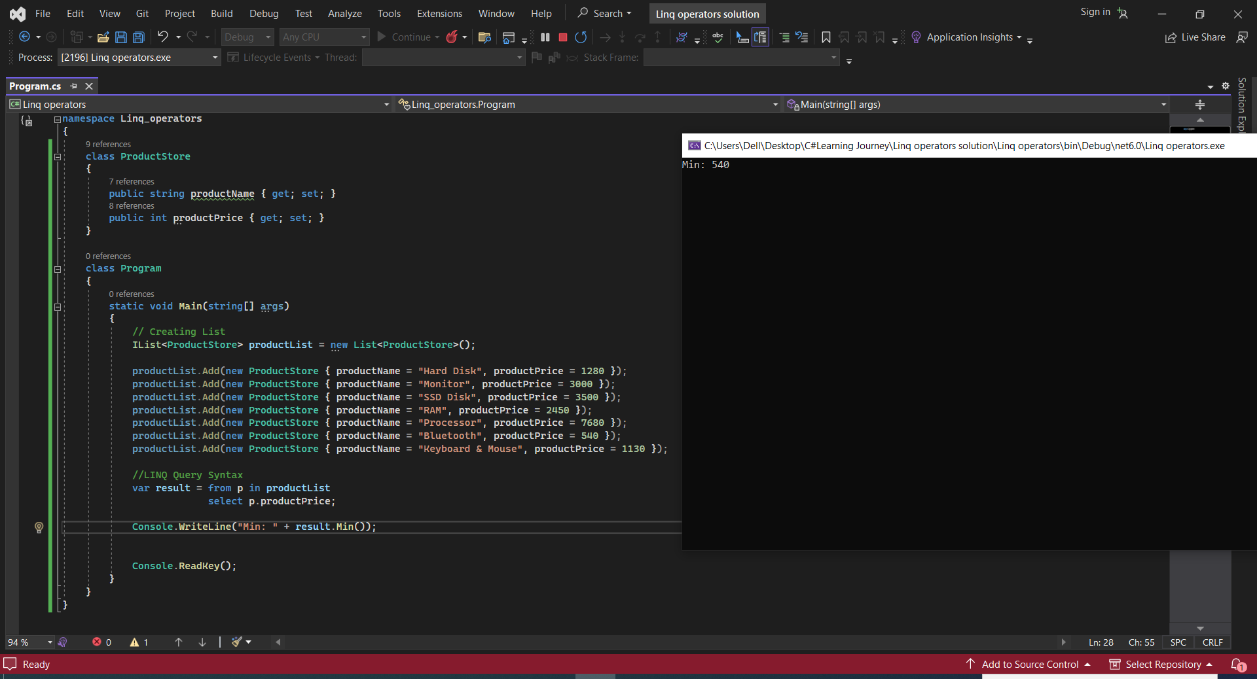

17.SUM

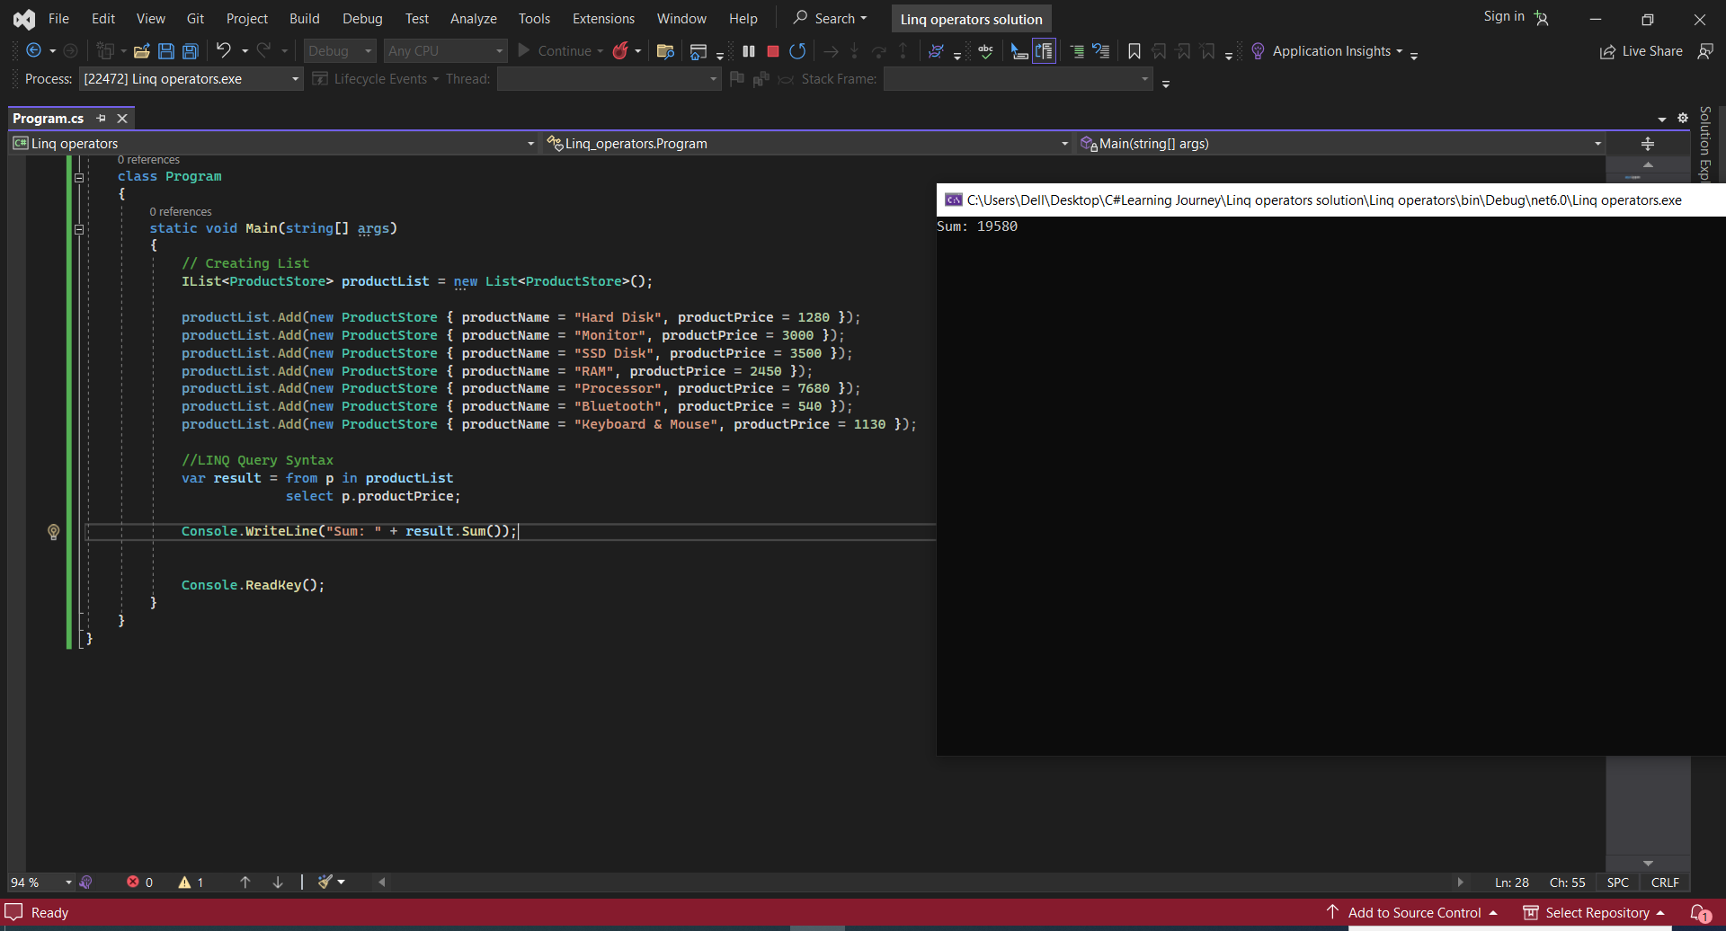

18.First Value

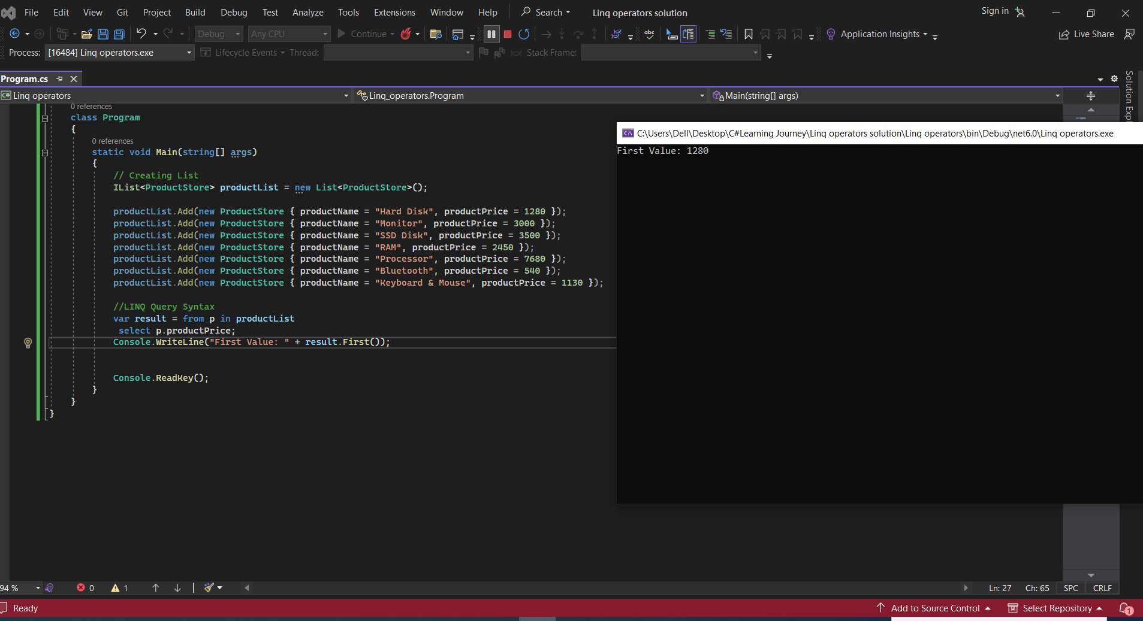

19.Last Value

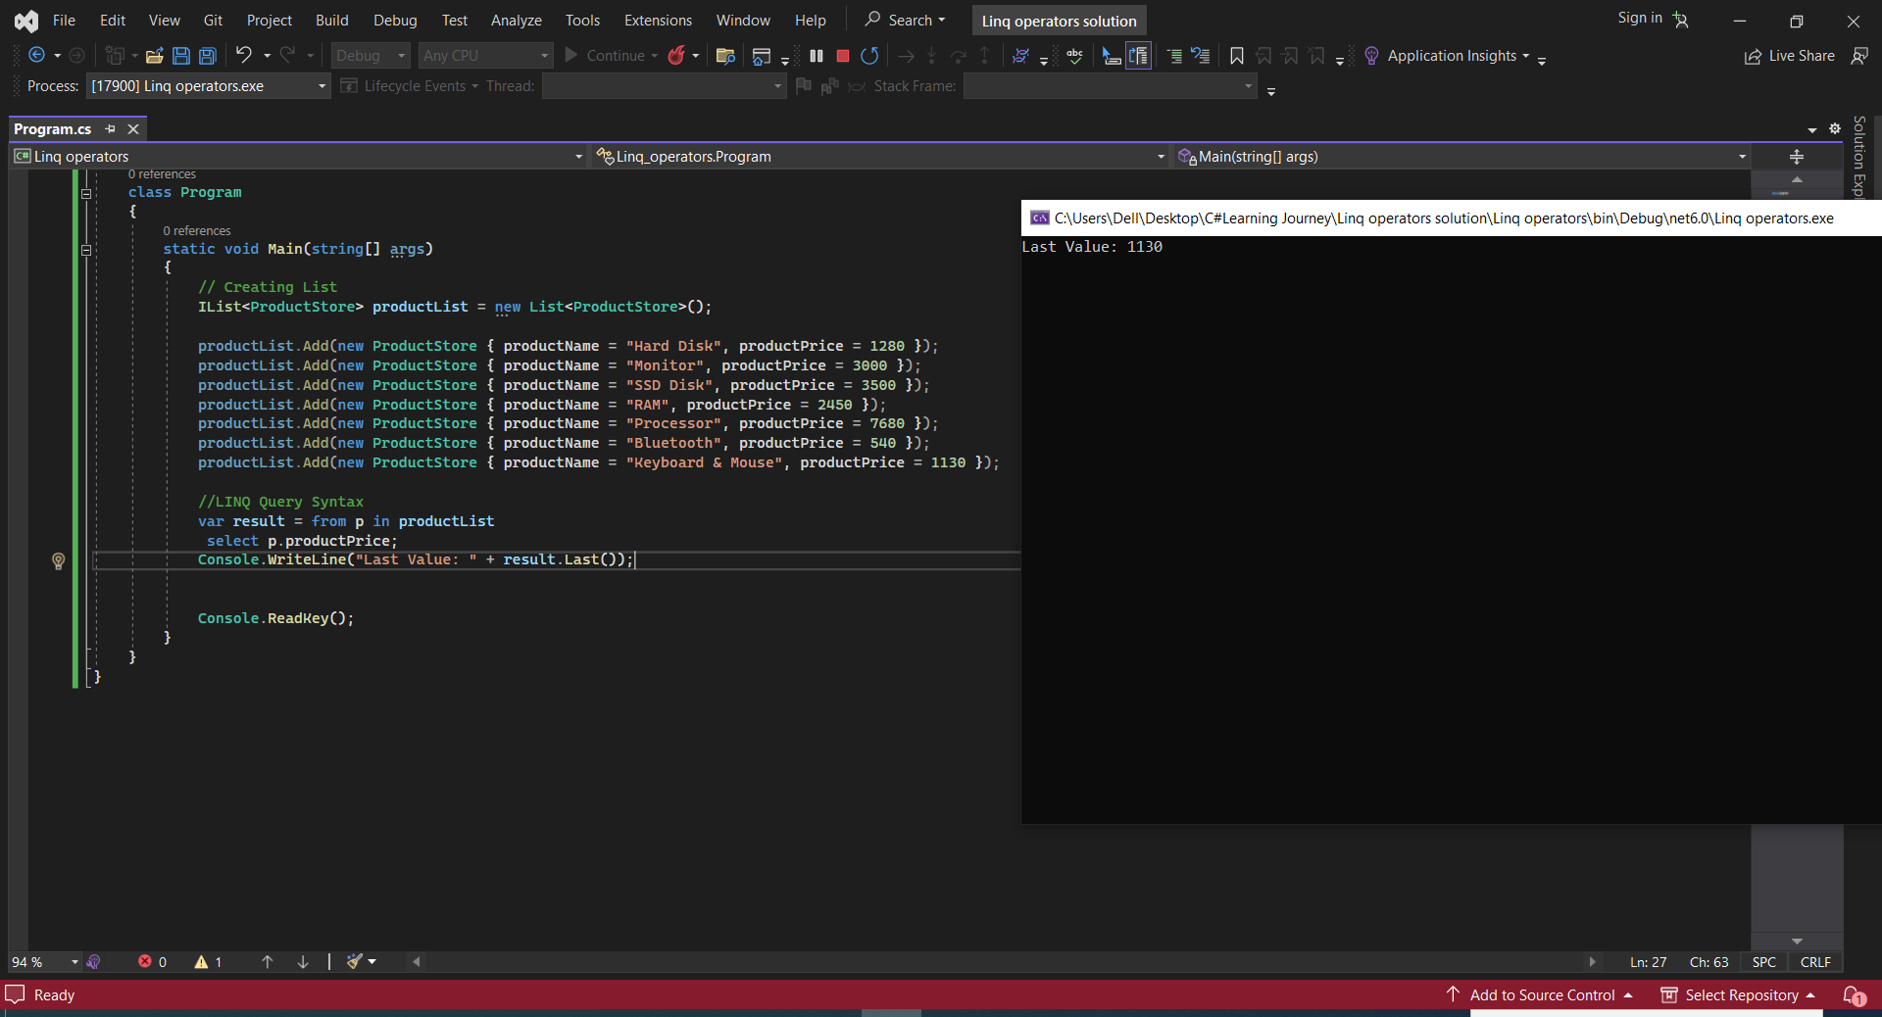

20.Contains

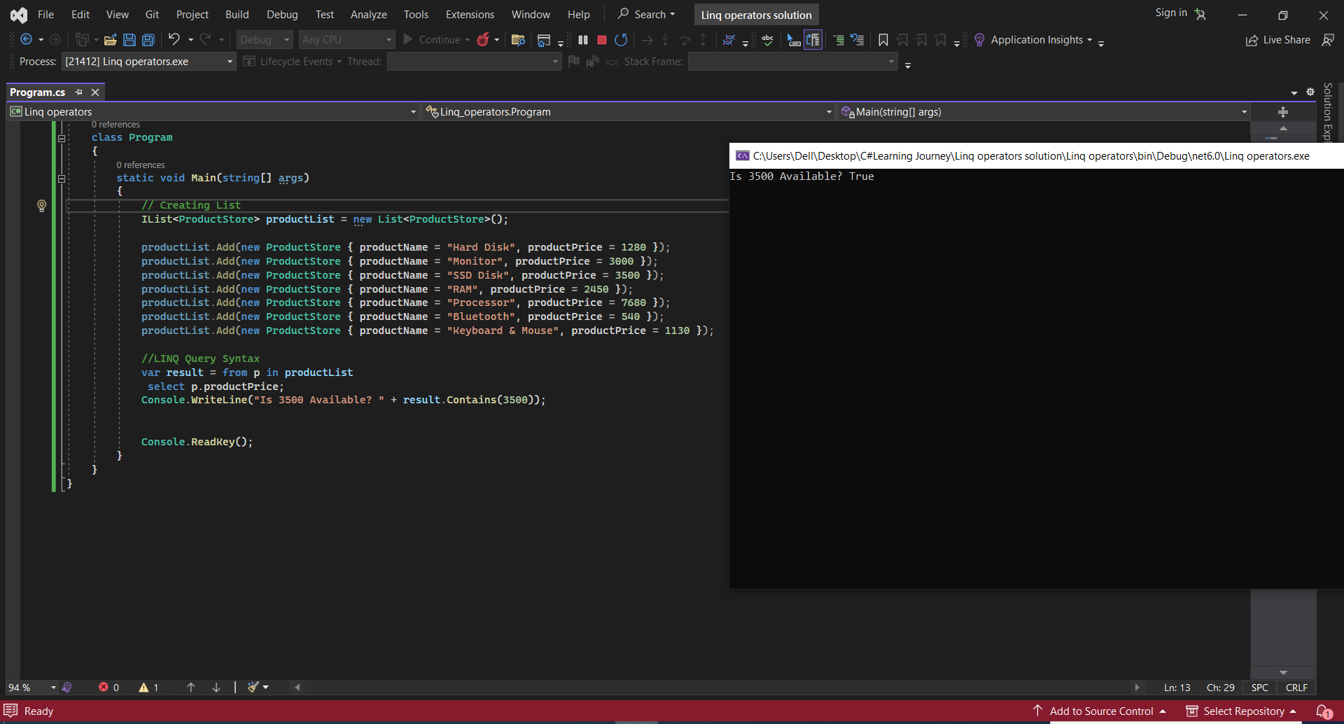

21. **ElementAt**

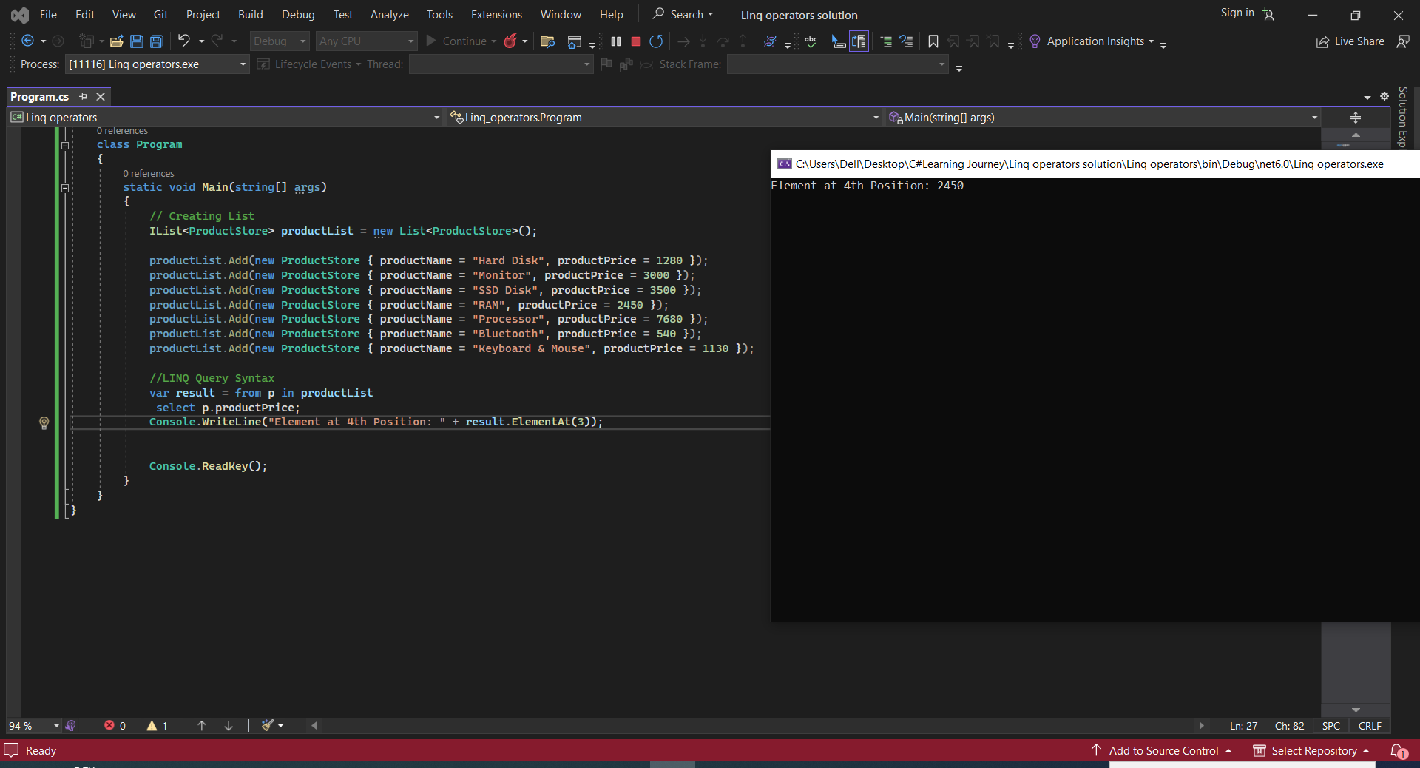

22. **Distinct**

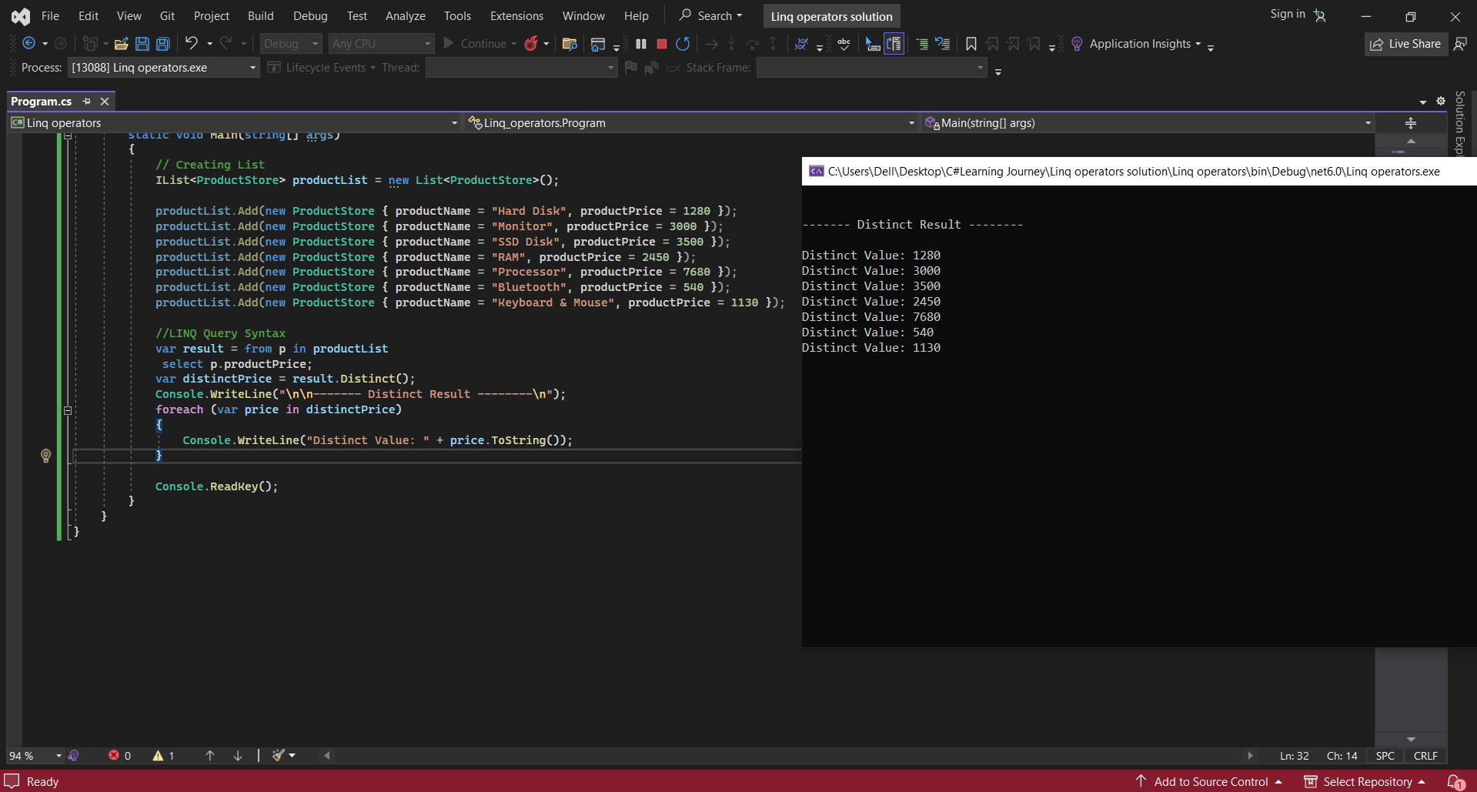

23. **All()** method scans whole list and returns true if all elements match the condition. If any of them doesn't fulfil the condition then it returns false.

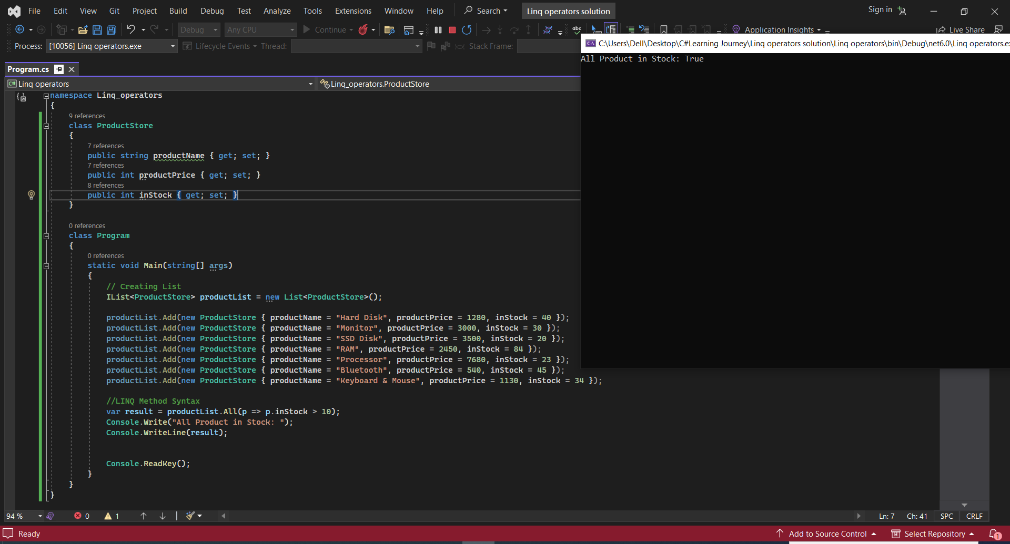

24. **Any()** Method scans whole list and returns true if any of the elements or all elements match the condition. If none of them match the condition then it returns false.

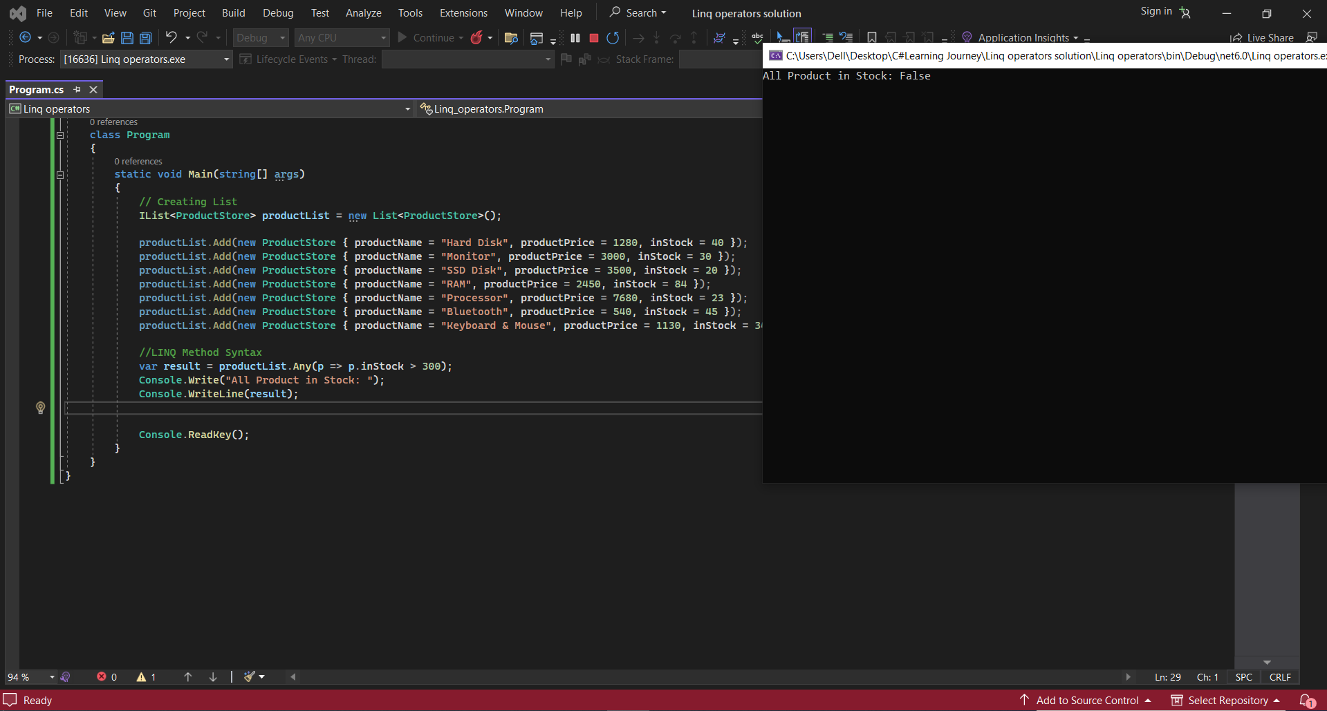

25. **Range** Method generates sequence of integral numbers within specified range.

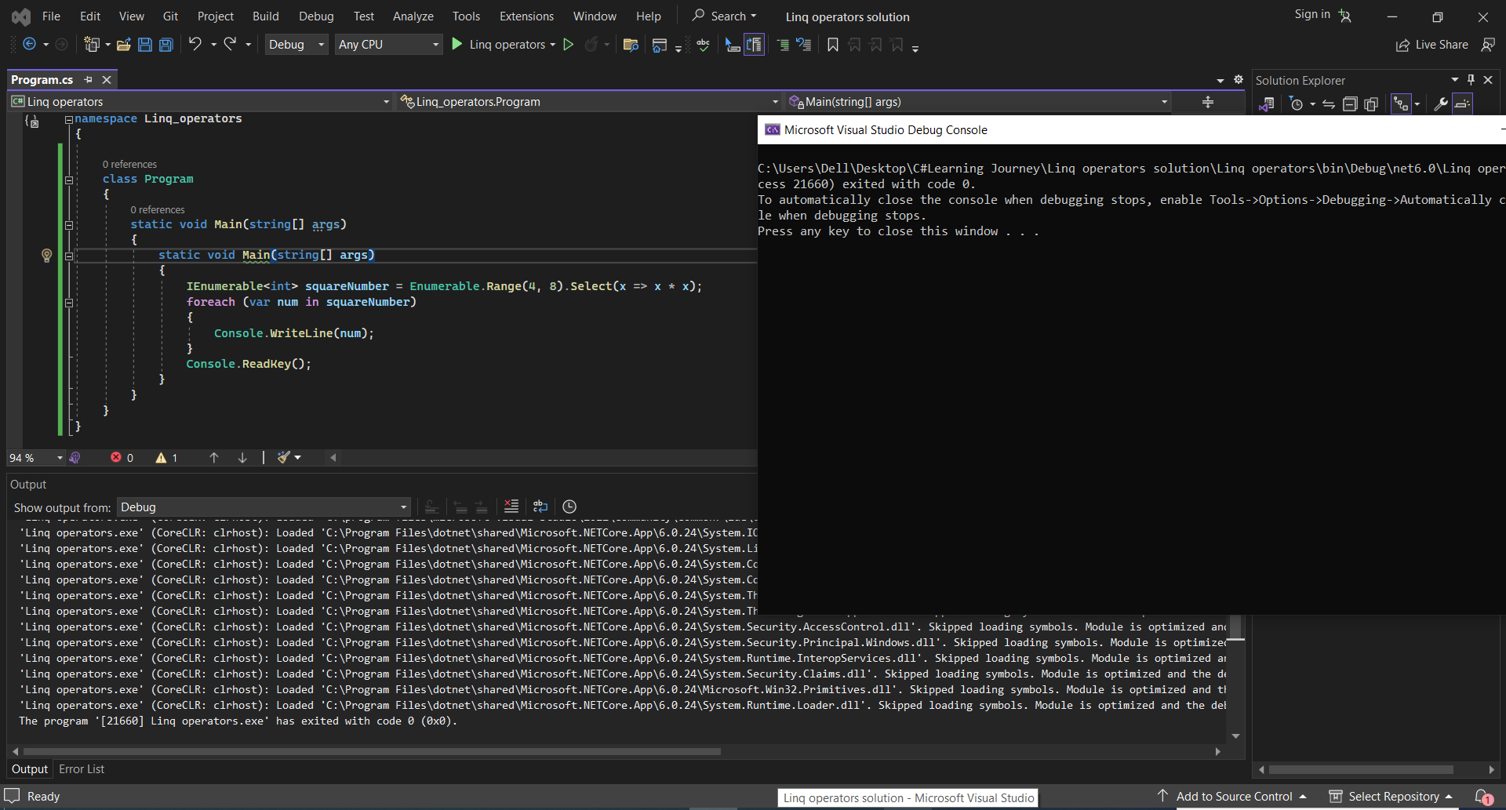

26. **Repeat** methods just repeats the integer value on the given number of times.

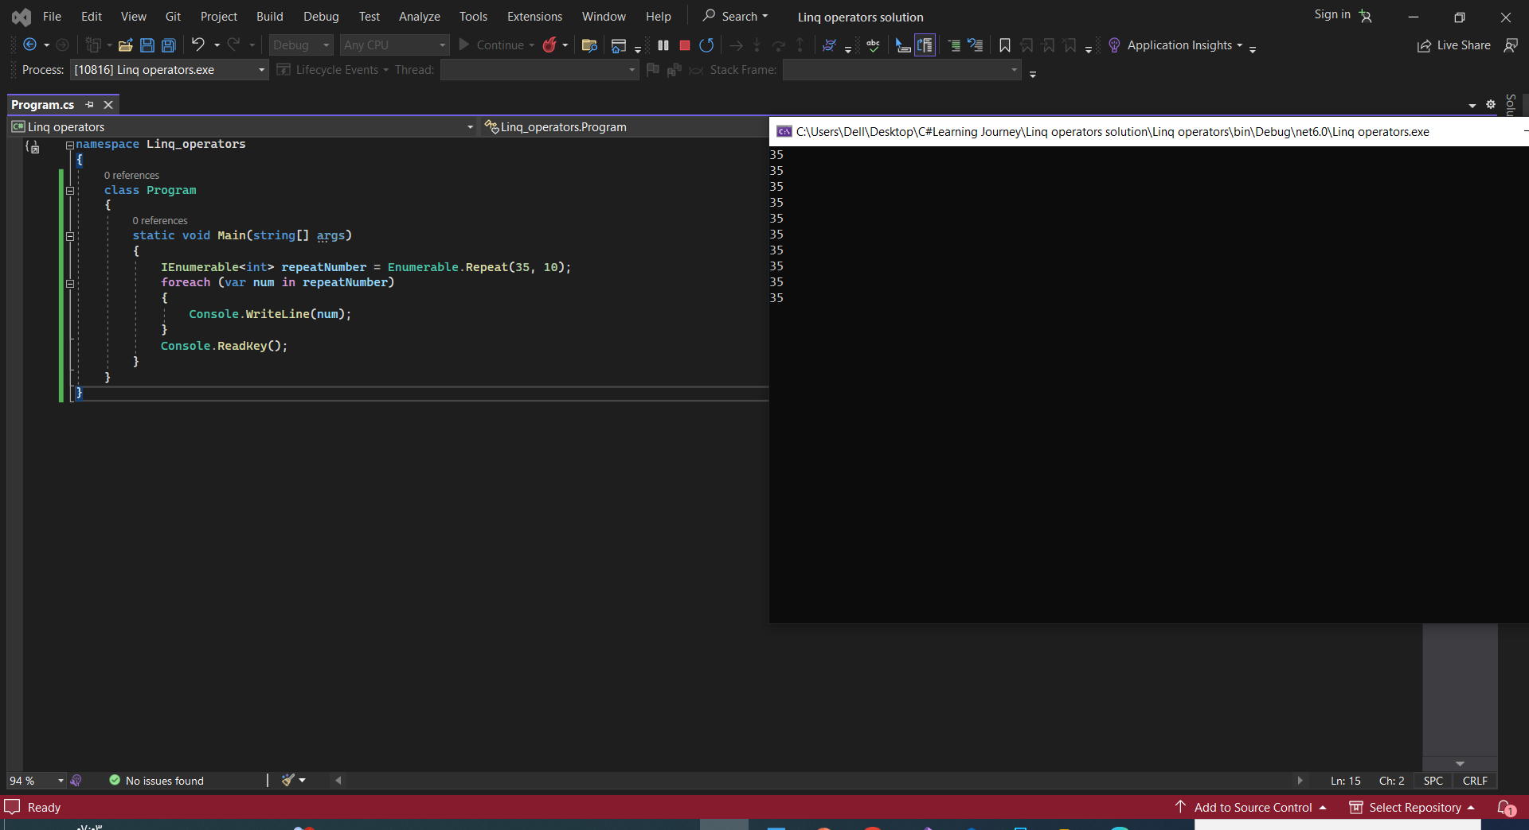

**27.Empty** method returns an empty collection or empty sequence.

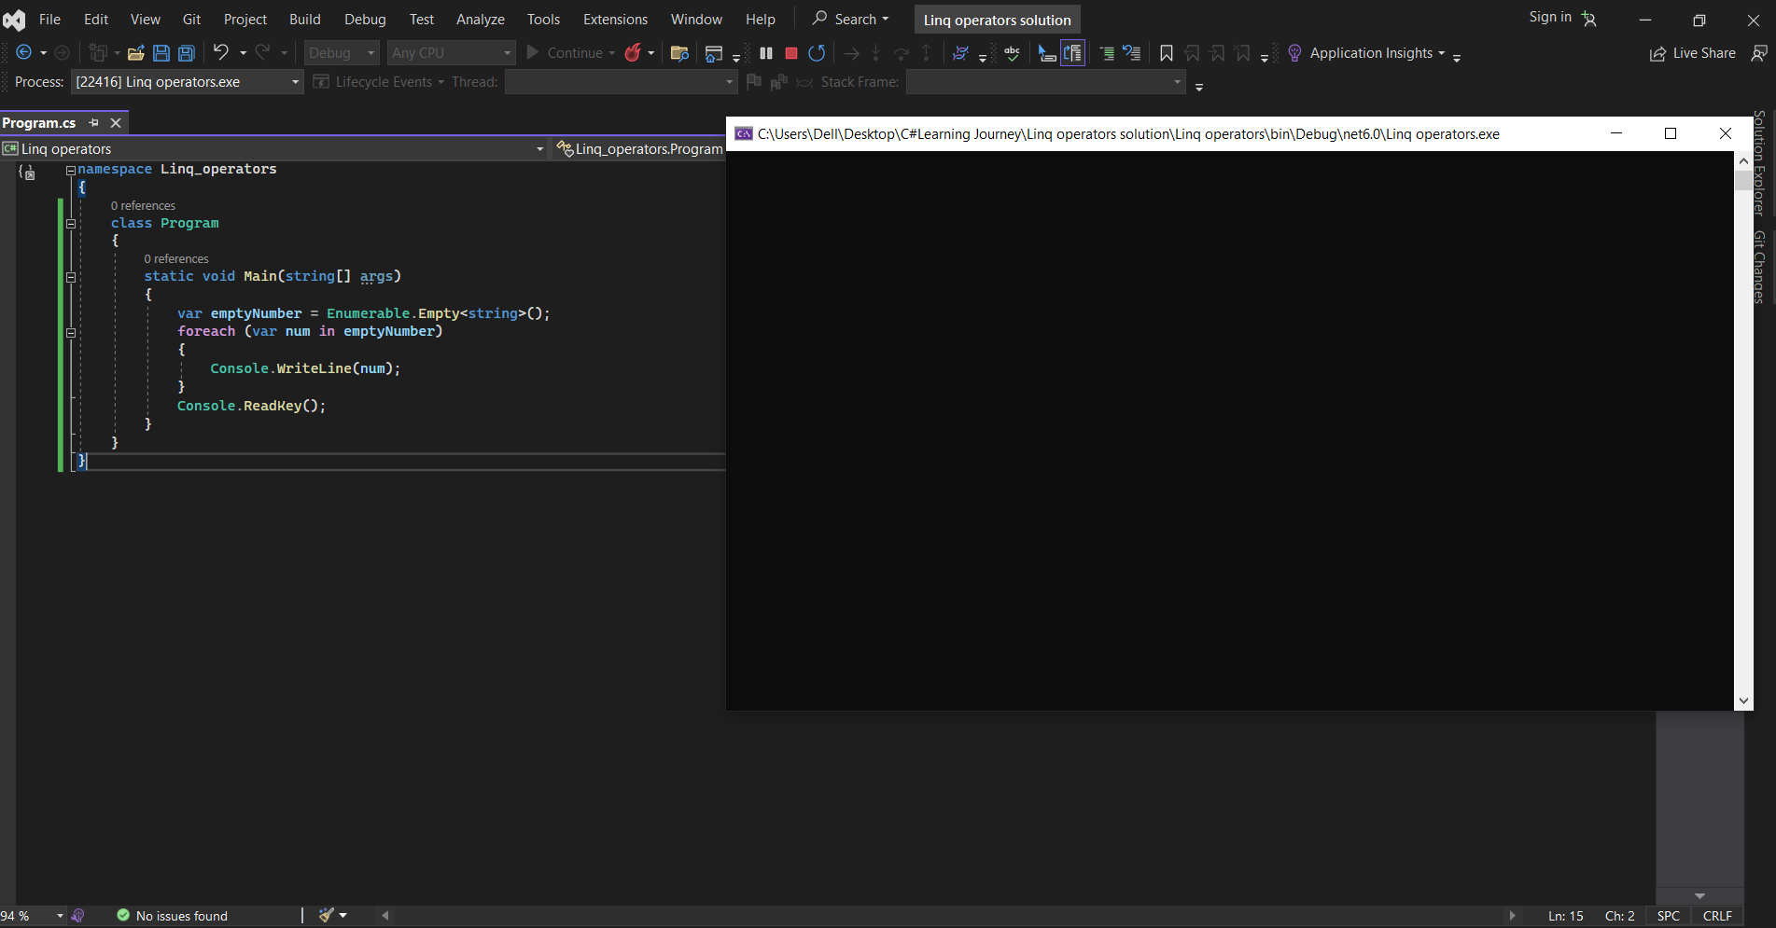

28.**LINQ with Array**

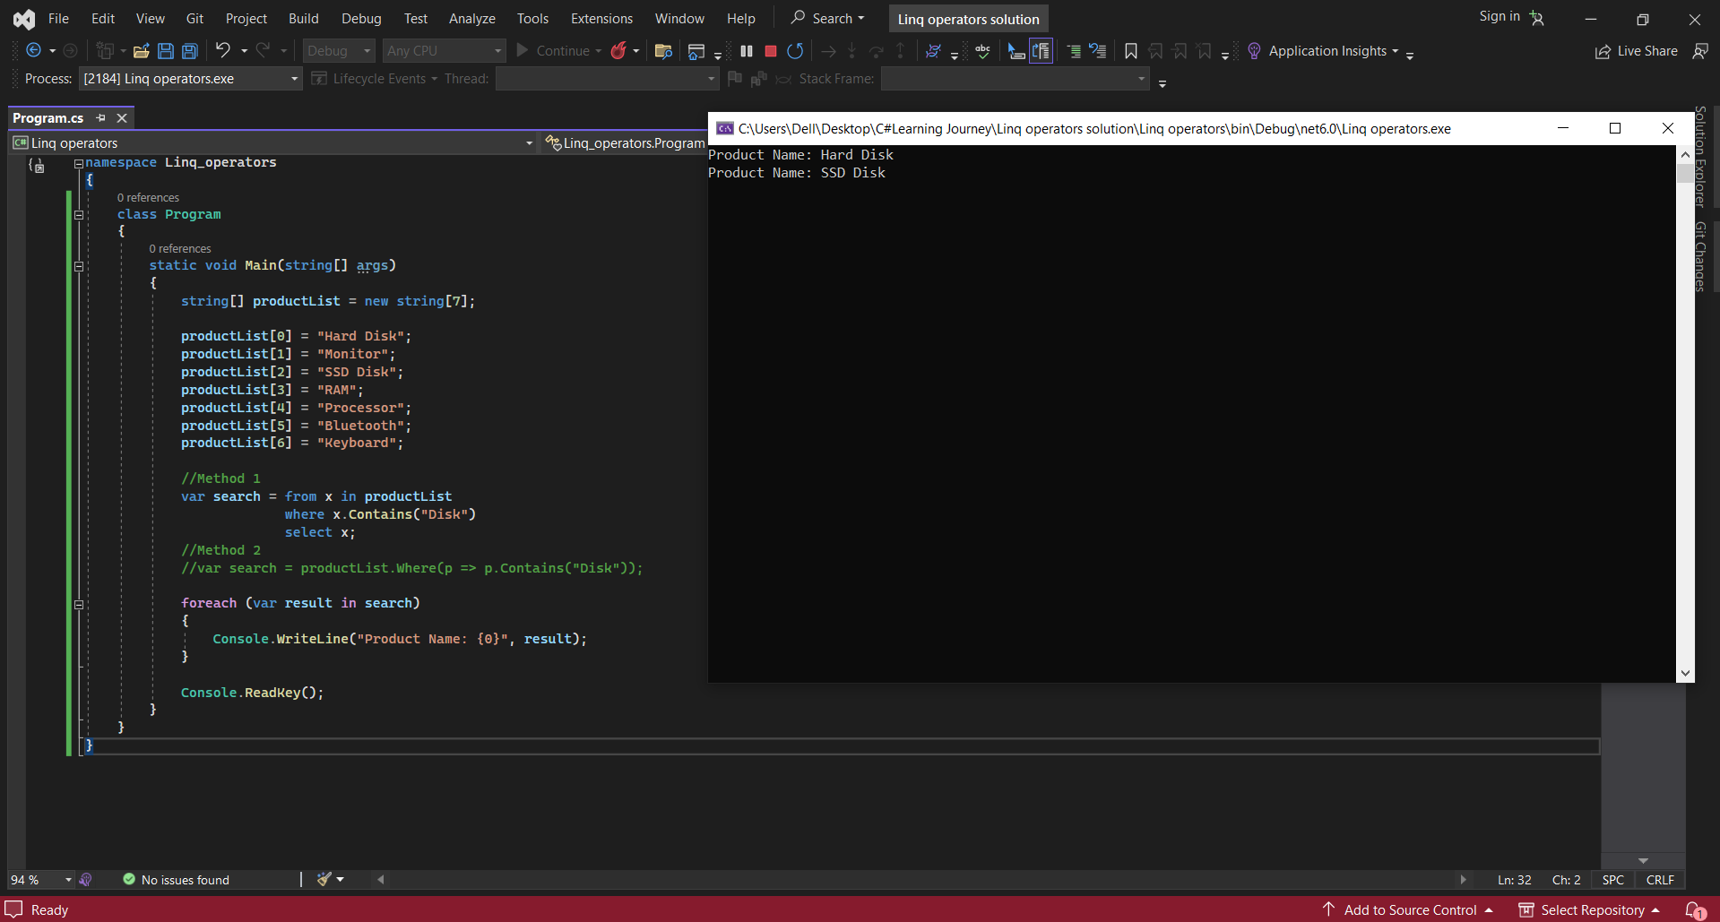

29. **ArrayList** is the part of **System.Collections** namespace and it allows to dynamically create array.

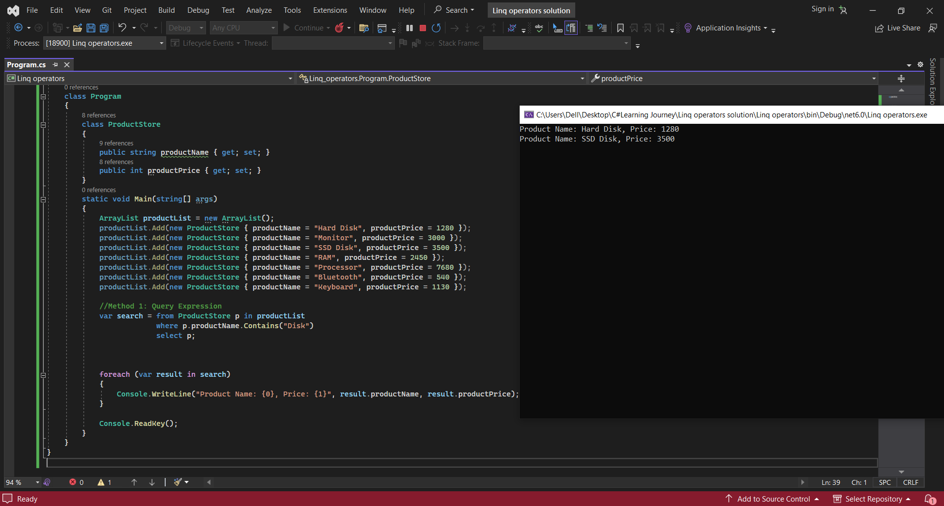

30. **Search Dictionary**

